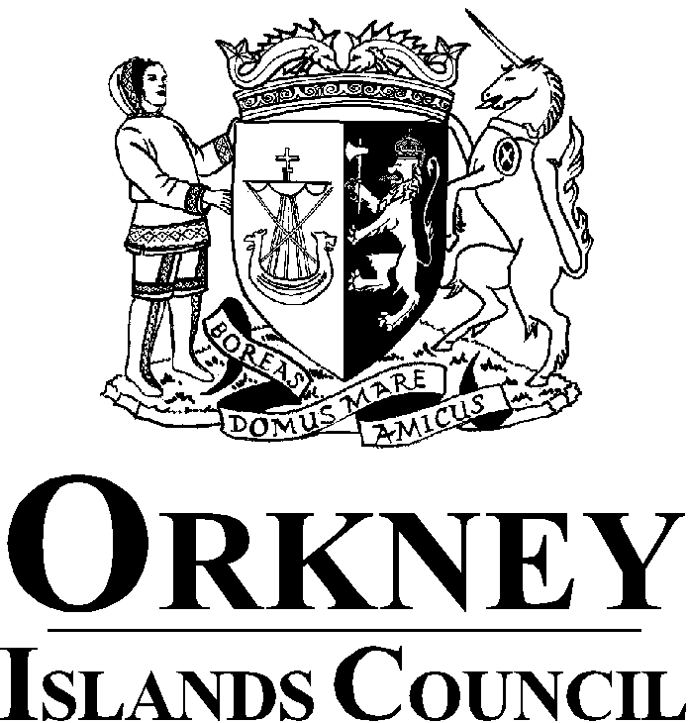ENVIRONMENTAL, PROPERTY AND IT SERVICES

Interim Executive Director: Hayley Green, MBA (Public Service)
Council Offices, Kirkwall, Orkney, KW15 1NY

Tel: (01856) 873535 Website: www.orkney.gov.uk
Fax: (01856) 876158 Email:

P5 Universal free school meals 06/12/2021

Dear Parent / Guardian

In line with Scottish Government Guidance, from January 2022 all Orkney schools will be offering universal free school meals to all P5 children attending school during term time. This follows a successful roll out of universal free school meals to all P4 children in August 2021.

Currently the Government has indicated that children in P6 and P7 will also be joining the Universal free school meal roll out in August 2022, this will enable all authorities across Scotland to put in place any adaptations / changes required to ensure a successful roll out.

We encourage parents to take the opportunity of ensuring their child has access to a healthy and nutritious meal every day they are in school. This benefits children in so many ways, the meals are all nutritionally balanced and comply with all current school food guidelines and legislation, this also helps children to focus and assists them to engage in learning.

Yours Sincerely

Mr Scott Pring

Orkney School Meals Catering Manager

